HONG KONG Q-MARK
PRODUCT CERTIFICATION SCHEME

NOTIFICATION OF CHANGES FORM

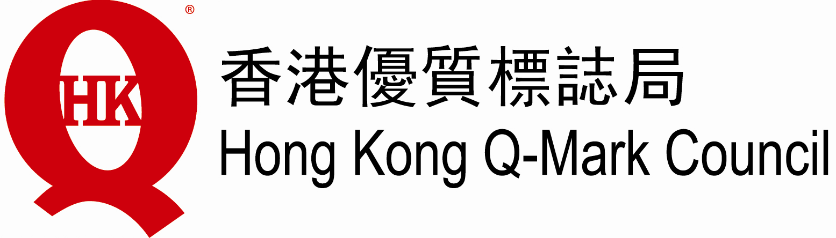
31/F, Billion Plaza, 8 Cheung Yue Street,
Cheung Sha Wan, Kowloon, Hong Kong.
Tel: 27323188 Fax: 27213494 E-Mail: qmd@fhki.org.hk

NOTIFICATION OF CHANGES
Name of organization |  |  | Cert. No.
Responsible Person |  |  | Date:
 | (Name) | (Signature)
Please return this form to Hong Kong Q-Mark Council accompanied by the required supporting documents if there are any changes or intended changes in your organisation in the following aspects.

Please tick the box(es) below as appropriate and complete the relevant section(s) of this form according to the instructions.
□ | (1) | Change in ownership or name of the organization
□ | (2) | Change in organisational structure, key staff or contact details
□ | (3) | Change in registered address or any premises of the organisation where certified product(s) are manufactured
□ | (4) | Change in manufacturing procedures and resources including personnel, equipment, facilities, working environment, where significant
□ | (5) | Any other matters that may affect the organisation’s capability, or its scope of product certification or its conformity with the product certification criteria

Please study carefully the relevant Hong Kong Q-Mark documents before completing this form.

(Please tick the box or boxes below as appropriate and provide the information / supporting documents as required.)
□ | (1) | Change in ownership or name of the organization
 | □ | - Change in name of organization  Please provide the following information with this form.  - For local or non-Hong Kong companies registered with the Registrar of Companies  A copy of the “certificate of change of name” (Cap 32, s22(1A)) for local companies or a fresh certificate containing the new name of the company for an overseas company (Cap 32, s335(3)), both issued by the Registrar of Companies  - For sole-proprietorship or partnership business, or incorporated companies which use a business name different from its corporate name for the certified organisation  A copy of the business registration certificate amended by the Business Registration Office of Inland Revenue Department  - For both (i) and (ii), a copy of Certificate of Incorporation where applicable
 | □ | - Change in legal identity  (e.g. the business of the organisation has been taken over by another legal entity)  If certification is to be continued, the following steps should be taken:  - A fresh application for product certification from the new legal entity has to be provided to Hong Kong Q-Mark Council, together with details of changes made or to be made and a report on how the operation of the organisation will be affected.  - If the product certification for the new legal entity is to be granted under the original registration number, a written request from the new legal entity has to be provided to Hong Kong Q-Mark Council. The original legal entity is also requested to write a letter to Hong Kong Q-Mark Council expressing that it wishes to terminate the certification of the organisation and that it has no objection to granting certification to the new legal entity using the original registration number.  - For both (i) and (ii), a copy of Certificate of Incorporation where applicable
 | □ | - Other change in legal, commercial or organisational status  (e.g., mergers, company dissolutions, bankruptcies, compulsory or voluntary liquidation or any other matters concerning the Official Receiver)  Description and details of the change

□ | (2) | Change in organisational structure, key staff or contact details
 | □ | 2.1 Change in organisational structure  Please provide the following information with this form.  - A brief description of the changes in organisation structure  - Original and updated organisation charts and relevant job descriptions
 | □ | 2.2 Change in key staff ¹  Description of the change  Please provide the following information with this form.  - Updated organisation chart  - Curriculum vitae of nominated personnel with copies of qualification documents  - Relevant job descriptions of personnel affected by the change
 | Note 1 | Key staff defined as personnel that may affect the fullfillment of the product certification criteria including factory/production manager, QA /QC manager, and responsible person, etc.
 | □ | 2.3 Change in public enquiry  If you wish to change the contact details for public enquiry, please provide the new information as follows:
  Name and post title of the enquiry person²
  Telephone
  Fax
  Email
  Website
 | Note 2 | Please provide the name and post title of the enquiry person in both Chinese and English, if applicable.

□ | (3) | Change in registered address or any premises of the organisation where certified product(s) are manufactured
3.1 Description of the change
(e.g. factory relocation/ renovation/ expansion, etc.)

3.2 Please provide the following information, where applicable, with this form before the start of the change except otherwise specified.
Before relocation/ renovation/ expansion:
- New address of the organisation
- Expected relocation/ renovation/ expansion start and end dates
- Proposed floor plan with the affected areas highlighted
- Assessment of how the operation will be affected
After relocation/ renovation/ expansion:
- Final floor plan with the affected areas highlighted
- Report validating that the affected areas are suitable for their intended use(s)

□ | (4) | Change in manufacturing procedures and resources including personnel, equipment, facilities, manufacturing environment, where significant
 |  | 4.1 Description of the change
 |  | 4.2 Certified product(s) that will be affected by the change
4.3 Certified product(s) that will be affected by the change
- Evaluation report
- New procedures
- Updated scope

□ | (5) | Other Changes³
 |  | 5.1 Description of the change
 |  | 5.2 Certified product(s) that will be affected by the change
5.3 Please provide the following information with this form.
- Report assessing the impacts of the above change
 | Note 3 | Other changes might include changes that may affect the organisation’s capability, or its scope of product certification, or its conformity with the product certification criteria.

